PUBLIC NOTICE
THIS HEREBY SERVES NOTICE THAT THE SOUTHFIELD DOWNTOWN DEVELOPMENT AUTHORITY BOARD OF DIRECTORS WILL HOLD ITS MEETING
VIA VIDEOCONFERENCE (BOARD MEMBERS)
CALL IN 248-796-5052 (PUBLIC)
ON

November 19, 2021 at 10:00 AM
PLEASE CALL THE SOUTHFIELD DDA IF YOU HAVE QUESTIONS.
WE MAY BE REACHED AT (248) 796-5196.
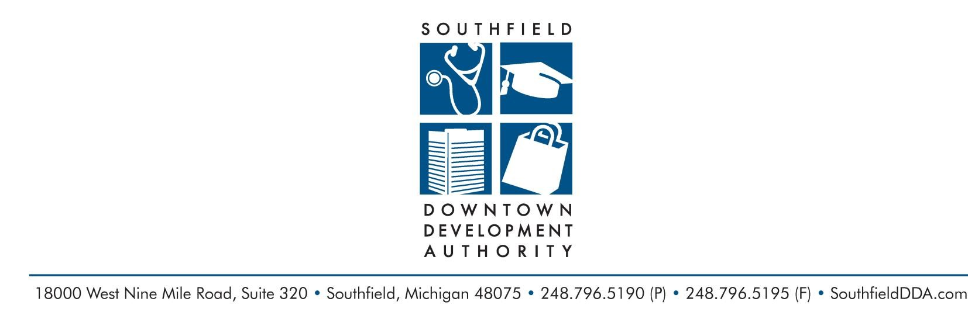
Respectfully Submitted,

Al Aceves
Executive Director
SOUTHFIELD DOWNTOWN DEVELOPMENT AUTHORITY
Serving the City of Southfield since 1988

James K. Ralph Jr., Chairman of the Board Elizabeth Rae, Secretary Ryan McKindles, Treasurer
Mayor Kenson J. Siver Dr. Steven Craig Dr. Jamii Hitchcock
W. Michael McFarland Aric Rusk Brant Russell
Brent Uhl Tory VanCobb

Al Ace ves Jr., Executive Director Melissa Adams, Assistant to the Executive Director

