PUBLIC NOTICE
THIS HEREBY SERVES NOTICE THAT THE SOUTHFIELD DOWNTOWN DEVELOPMENT AUTHORITY BOARD OF DIRECTORS WILL HOLD ITS INFORMATIONAL BOARD MEETING
(BOARD MEMBERS & PUBLIC)
18000 West Nine Mile, suite 1507
Southfield, MI 48075
ON

March 25, 2022 at 8:00 AM
PLEASE CALL THE SOUTHFIELD DDA IF YOU HAVE QUESTIONS.
WE MAY BE REACHED AT (248) 796-5196.
TO JOIN BY PHONE DIAL IN AT (248) 796-5251
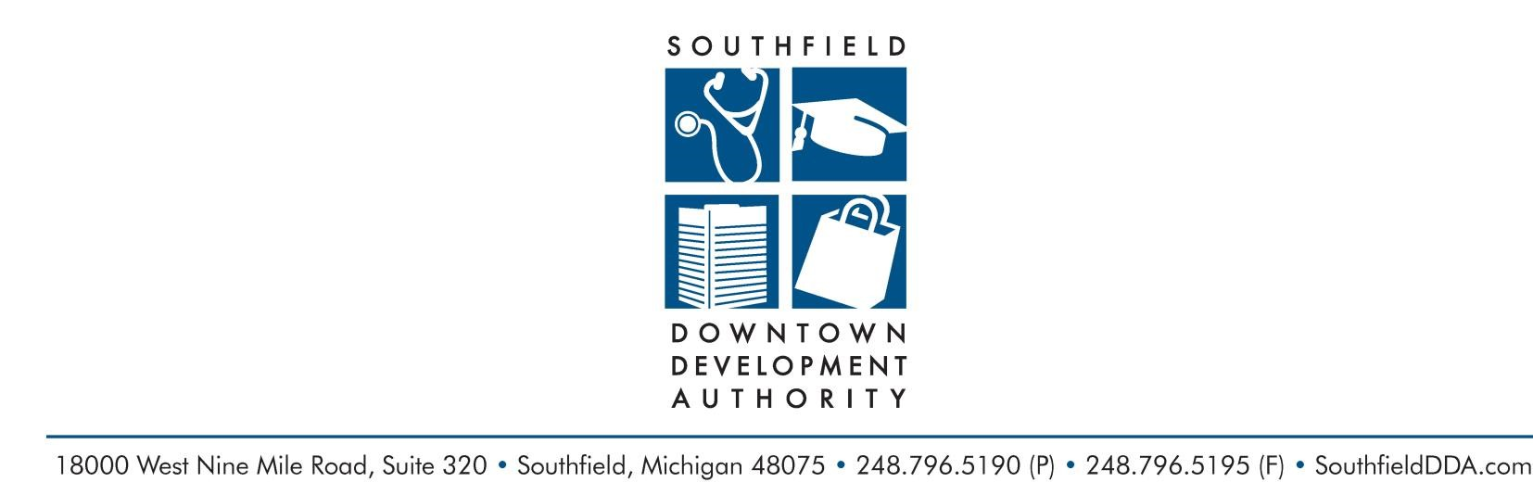
Respectfully Submitted,

Al Aceves
Executive Director
SOUTHFIELD DOWNTOWN DEVELOPMENT AUTHORITY
Serving the City of Southfield since 1988

James K. Ralph Jr., Chairman of the Board Elizabeth Rae, Secretary Ryan McKindles, Treasurer
Mayor Kenson J. Siver Dr. Steven Craig Dr. Jamii Hitchcock
W. Michael McFarland Aric Rusk Dr. Roland Cruickshank
Brent Uhl Tory VanCobb
Al Ace ves Jr., Executive Director Christine Zyla, Assistant to the Executive Director

